History
Long-Term Plan 2025-26
Equipping Children for a World of Possibilities
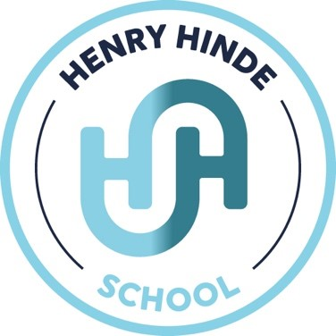

(subject)

Curriculum Intent: Equipping Children for a World of Possibilities.

History Intent:
To develop children’s understanding of History by instilling curiosity about inspirational people and events that helped shape and change the world as we know it now.

History IMPLEMENT:
EYFS/KS1
History is taught as a whole class and is often in blocks where the year groups learning challenge relates to subject. However, where possible the Learning Challenge driver (e.g. History) is taught cross curricular including writing.
Each year group’s frequency for delivery of the subject is slightly different:
Reception – There are one or two Learning Challenge sessions per week. These may cover aspects of history.
Year 1 and 2- In 2025-26, these are mixed age classes. There is one lesson each week which is either history or geography depending on the Learning Challenge driver.
Provision for DAP, SEND and EAL is decided on by class teacher depending on the specific needs of the children in each cohort. This might be pre-teaching specific vocabulary needed, using communicate in print visuals to help acquisition of new vocabulary, having a mixture of practical and recording skills, varying the way children record their learning or the depth of thinking the children are required to do.

KS2
History is implemented at Henry Hinde School through engaging lessons that help pupils understand the past and how it shapes the present. Teachers use storytelling, timelines, artefacts, and historical sources to bring different periods to life. Pupils take part in discussions, research projects, and themed activities that develop their enquiry skills and critical thinking. Educational visits, workshops, and role-play activities also help deepen understanding. Through these approaches, children learn about significant events, important figures, and different civilisations while developing a sense of chronology and historical awareness.
Disadvantaged pupils, pupils with English as an additional language (EAL), and children with special educational needs (SEN) are supported through inclusive and targeted approaches to ensure they can access the history curriculum successfully. Disadvantaged pupils are supported through additional resources, intervention groups, and financial assistance to ensure full participation in trips and enrichment activities. Pupils with EAL benefit from key vocabulary pre-teaching, visual aids, simplified texts, and structured discussions to help them understand historical concepts and develop language skills. Children with SEN receive differentiated tasks, scaffolded resources, adapted questioning, and support from teaching assistants where needed. Teachers regularly assess progress and adapt lessons to meet individual needs, ensuring all pupils can engage with and succeed in history.


Whole School Curriculum Map
 | Reception | Year 1 | Year 2 | Year 3 | Year 4 | Year 5 | Year 6
Autumn Term | How have homes changed?  Christmas in the Victorian times. | Heroes through history- Mary Anning and Amelia Earhart | Heroes through history- Mary Anning and Amelia Earhart | Stone Age, Bronze Age and Iron Age | The Victorians | Ancient Egyptians and Ancient Mayas | World War II
Spring Term | Geography focus- no history in Spring Term | Heroes through history- Louis Braille, Martin Luther King, Rosa Parks, Chales Dickens  Significant individuals- Christopher Columbus, Ernest Shackleton, Robert Faulkan Scott  Local history- Frank Whittle, William Webb Elliss  The first aeroplane flight | Heroes through history- Louis Braille, Martin Luther King, Rosa Parks, Chales Dickens  Significant individuals- Christopher Columbus, Ernest Shackleton, Robert Faulkan Scott  Local history- Frank Whittle, William Webb Elliss  The first aeroplane flight | Shang Dynasty of Ancient China | The Tudors | Medieval Monarchs | Crime and Punishment
Summer Term | Transport in the past  Changes in ourselves from birth and within reception. | Significant individuals- Neil Armstrong  Events beyond living memory- Great Fire of London  History of toys | Significant individuals- Neil Armstrong  Events beyond living memory- Great Fire of London  History of toys | Ancient Greece | The Roman Empire | Anglo-Saxons and Vikings (and Scots) | Significant People in History

