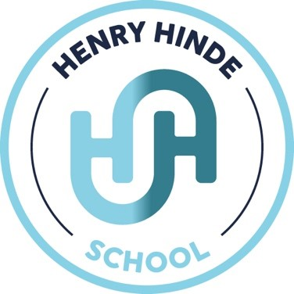
Subject Leader Plan

2025-26

Subject Development Plan 2025 - 2026 – Science
Target 1
1 |  | To know that pupils have a wider historical vocabulary.
How will I know |  | - Pupils are able to use scientific vocabulary within their work.  - Pupils are able to use scientific vocabulary when talking about their learning  - Pupils can confidently share their learning when speaking to members of the school community
Ref | Learning Intention |  | Actions | Success Criteria | Timescale | Resources | Responsible | Evaluation
1.0 |  |  | - Vocabulary lists are developed by the subject leader. | - Vocab lists are available on the drive with front covers for each topic. | Beginning of each new topic. |  | AB
Ref | Learning Intention |  | Actions | Success Criteria | Timescale | Resources | Responsible | Evaluation
1.1 |  |  | - Teachers ensure that vocabulary needed for each lesson is shared on the start of their slides and children use the definitions to fill in their vocab lists. | - Children have a completed vocabulary list by the end of each topic that they can refer back to. | At the beginning of each topic. |  | All teachers
Ref | - Learning Intention |  | - Actions | - Success Criteria | Timescale | Resources | Responsible | Evaluation
1.2 |  |  | - Monitor the explicit teaching of subject specific vocabulary during Science lessons. | - Evidence in books.  - Planning trawl. | Throughout topics. |  | AB
Ref | - Learning Intention |  | - Actions | - Success Criteria | Timescale | Resources | Responsible | Evaluation
1.3 |  |  | - Teachers plan a ‘going deeper’ task for each lesson (where appropriate) which encourages children to think critically and explain their reasoning, therefore giving them the opportunity to demonstrate a greater depth understanding. | - Evidence in books  - Planning trawl | End of each topic. |  | All teachers
Ref | - Learning Intention |  | - Actions | - Success Criteria | Timescale | Resources | Responsible | Evaluation
1.4

Target 2
2 |  | To improve the subject knowledge of teachers within history.
How will I know |  | - Teachers are confident in teaching the science topics for their year groups.  - Children make at least expected progress in all groups  - Pupils in turn have good subject knowledge
Ref | Learning Intention |  | Actions | Success Criteria | Timescale | Resources | Responsible | Evaluation
2.0 |  |  | - Yearly overview shared with staff on the scientific topics they will be covering this year. | - Emails sent.  - Available on drive.  - Hard copies in folder. | Beginning of each term. |  | AB
Ref | Learning Intention |  | Actions | Success Criteria | Timescale | Resources | Responsible | Evaluation
2.1 |  |  | - Teachers plan a ‘going deeper’ task for each lesson (where appropriate) which encourages children to think critically and explain their reasoning, therefore giving them the opportunity to demonstrate a greater depth understanding. |  |  |  | All teachers
Ref | Learning Intention |  | Actions | Success Criteria | Timescale | Resources | Responsible | Evaluation
1.4 |  |  | - Teachers create shared plans as a team to ensure that curriculum knowledge is strong enough. | - Evidence in books  - Planning trawl | Beginning of each topic |  | All teachers

Target 3
3 |  | To ensure that the learning behaviours around school are of a high standard.
How will I know |  | - Pupils are demonstrating active listening skills  - Pupils are able to confidently discuss their learning  - Pupils’ are productive within lessons  - Presentation in books is good
Ref | Learning Intention |  | Actions | Successs Criteria | Timescale | Resources | Responsible | Evaluation
3.0 |  |  | - Ensure a range of activities are planning which engage children including drama, role play and active learning. | - Lesson observations  - Learning walks  - Pupil voice | Throughout year |  | All teachers
Ref | Learning Intention |  | Actions | Success Criteria | Timescale | Resources | Responsible | Evaluation
3.1 |  |  | - Ensure high levels of expectations are held by all adults for all children (in terms of behaviour, learning behaviours and presentation) within school during each subject. | - Lesson observations  - Learning walks  - Pupil voice | Throughout year |  | All teachers
Ref | Learning Intention |  | Actions | Success Criteria | Timescale | Resources | Responsible | Evaluation
3.2
Ref | Learning Intention |  | Actions | Success Criteria | Timescale | Resources | Responsible | Evaluation
3.3

